

Business Requirements Definition

For
Space Range and Display
Sales Aggregation

Version: 0.5

Date: 19/03/07

Status: DRAFT

Authority: | Business Sponsor (International Operations Development – Best Practice)
Signature:
Authority: | Business Sponsor (International Operations Development/Local Change Manager)
Signature:
Authority: | Group Technology & Architecture (Enterprise Architect)
Signature:

Table of Contents
1. Introduction 4
1.1 Background 4
1.2 Objectives 4
1.3 Assumptions 4
1.4 Project Scope 5
1.5 System Scope 5
1.6 People Scope 6
1.7 Process scope 6
2. Current Business 7
2.1 Current ‘As-Is’ Business Processes 7
2.1.1 Turkey 7
2.1.2 US 7
3. To-Be Business Requirements 8
3.1 Requirements Catalogue 8
4. Business System Options 13
5. Outstanding Issues/Questions 13
6. Project Phase Sign-Off 13

Document Control

Project: | Space Range and Display – Sales Aggregation
Document Title: | Business Requirements Definition
Document Location: | team workroom
Distribution: | Project Library  Steve P Miller  Emma Kenyon  John Cowper  Eva Hotmarova | Samantha Baptiste  Hilary Waterhouse  Eleanor Koniecko  Mary Welch

Change Record

Date | Version | Change Description | Author
05/03/2007 | 0.1 | Initial Draft | Sudha Vaidyanathan
08/03/2007 | 0.2 | Updated version capturing SRD team feedback | Sudha Vaidyanathan
12/03/2007 | 0.3 | Updated version capturing more descriptive requirements | Sudha Vaidyanathan
14/03/2007 | 0.4 | Version for sign off | Sudha Vaidyanathan
18/03/2007 | 0.5 | Version for sign off with detailed requirement | Sudha Vaidyanathan

Introduction

The Space, Range and Display (SRD) stream within Group IT has identified a need to summarise sales data to assist with Ranging and Display. In the Tesco Operating Model (TOM), there is a need to source this sales data, and present it to the SRD systems for summarisation across a cluster of stores (or all stores), a (display) group of products, and one or more weeks, up to 2 years of history.
This aggregated sales history data will be available to Range system and JDA to generate store ranges and Planograms.

Background

The Tesco Operating Model is being rolled out to Tesco Group. Space, Range and Display Systems are part of the Tesco Operating Model.

The requirement described in this document is one of the gaps identified between Best Practice processes and current Group systems. This requirement is viewed as a Tesco Group requirement and supports group repeatable best practices.

Objectives

The objective of this document is to formally document the Sales Aggregation requirements, with respect to Space, Range and Display Project. The sign off of this document will provide the basis on which to commence the Business Systems Design phase of the project.

Assumptions

- The sales data will be sourced from ORMS, “TranDataHist”. The extracted data would be held and maintained in Sales History (Sales Aggregation specific) data repository for 2 years of history.
- The level of data coming into Sales History database from ORMS would be product by week by store.
- The frequency of data load into Sales History database is a weekly routine.

Project Scope

This document will address the requirements for Sales Aggregation system. The Project scope is within Sales Aggregation, Sales History database, House keeping for SRD specific database and Sales data extraction from the ORMS.

System Scope

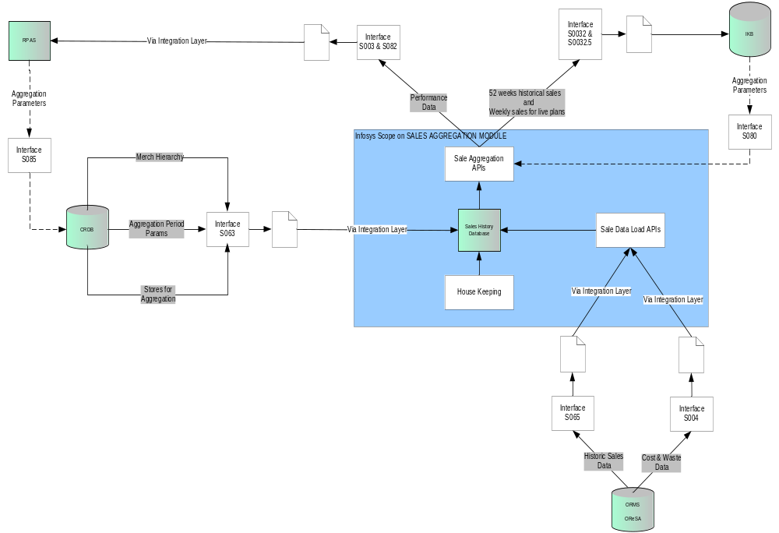

The System impacts may be identified during the production of the Business System Design and Technical Solution Design documents.

People Scope

Group Process Design (Group IT) |  | ORMS Development
International Operations Development (IOD) |  | SRD Systems Development
HSC Deployment |  | Integration Layer Development
Local In Country Business |  | Group Technology & Architecture

Further people impacts may be identified during the production of the Business System Design and Functional Specification.

Process scope

Tesco Operating Model

Level 0 | Level 1 | Level 2
 | Floor Planning
 | Planogramming
 | Range Planning

Current Business

Current ‘As-Is’ Business Processes

Turkey
- Currently in Turkey, there is some historic sales data available for planning the space and range. This sales data needs to be extracted into Sales History database.

US
- The US business is a start up and therefore currently has no stores that are open and trading. There is no Sales historic data available for planning the space and range.

To-Be Business Requirements

Requirements Catalogue

Requirement ID: SR001 | Source: Tesco Operating Model | Owner: Janet Smith | Priority: Must Have
Requirement Name:
The system must be able to supply customized sales data in response to requests received in some pre-determined format. Pre-determined refers to Sales Performance details.

Requirement Description:
For Phase 1, the system receives sales data requests from SRD Controls (CRDB) on behalf of Ranging System and JDA (IKB).
- The sales data request from CRDB will be based on Display Hierarchy, History Period and Stores in Clusters.
- The sales data request from IKB database will be based on Products, Planograms, Floor plans and Stores.
- The frequency of these requests would be based on User action.

Benefits: one system to create all summarization required for SRD.

Comments / Suggested Solutions:
The System receives sales data request from CRDB and IKB via the integration layer. The existing UK extract programs (Interfaces S063 & S080) will be used to minimise changes.

Related Requirements:
SR002 & SR003

Requirement ID :SR002 | Source : Tesco Operating Model | Owner : Janet Smith | Priority :Must Have
Requirement Name:
The System must be able to send the requested format of sales performance data to RPAS.

Requirement Description:
The system must send aggregated sales performance data to RPAS based on Display Hierarchy, History Period and Stores in Clusters.

Benefits: Sales performance measures will be accurately available to Ranging systems for setting up of ranges.

Comments / Suggested Solutions:
- The System sends sales performance data to RPAS via the integration layer. The existing UK extract programs (Interfaces S003 & S082) will be used to minimise changes.
- The response sales data format is as below.
Field
Event_ID
Store_Range_Group_ID (Store Cluster)
Space_Break_Code
TPNB (Product ID)
Average Weekly Sales Value (ex.VAT)
Average Weekly Sales Units
Average Weekly Sales Weight
Average Weekly Number of Stores (sales)
Average Weekly Waste Value
Average Weekly Number of Stores (waste)
Average Weekly Margin Value
Average Weekly Number of Stores (margin)

- The Sales history for implemented plans will be based on the history period will be a rolling 52 weeks for Version 1
- The Sales history will be customized exactly for each Range i.e. sales will be aggregated only from stores in the store cluster and with the range class that the Range relates to.
- The system will generate performance data based on waste, margin and other key elements
- Weeks with zero sales will be excluded from the calculation. Similarly, calculations of other performance measures which register zero in any week will exclude that week.
- Each performance measure will be calculated independently of the others i.e. a week with zero sales will not influence the calculation of average margin.
- No provision is available to produce an individual sales figure for any multi-located product, as sales/shelf is not captured.

Related Requirements:
SR001

Requirement ID :SR003 | Source : Tesco Operating Model | Owner : Janet Smith | Priority :Must Have
Requirement Name:
The System must be able to send actual and historic sales data to IKB.

Requirement Description:
The System must be able to send actual and historic sales data to IKB according to the specified format and level of aggregation (based on Products, Planograms, Floor plans and Stores). The historic data would be for an aggregation period and the actual would be at a weekly level.

- This data is required at 4 aggregation levels as follows:

 | Level of aggregation | Description | Current relevant UK table
1 | Product | The average weekly sales of each Product across all Stores | CSG_Product_Performance_Data
2 | Product / Planogram | The average weekly sales of each Product on a Planogram across all Stores with that Planogram | CSG_Product_POG_Performance_Data
3 | Planogram | The average weekly sales of each Planogram (all Products) across all Stores with that Planogram | CSG_Planogram_Performance_Data
4 | Planogram / Store | The average weekly sales of each Planogram (all Products) at each Store | CSG_POG_Store_Performance_Data

Benefits: Aggregated sales data will be accurately available to JDA.

Comments / Suggested Solutions:
- IKB needs a weekly feed of data from the System. (The existing UK model of Sales Aggregation handles this response using Interfaces S0032 & S032.5)

- Each performance measure will be calculated independently of the others i.e. a week with zero sales will not influence the calculation of average margin.

- Weeks with zero sales will be excluded from the calculation. Similarly, calculations of other performance measure which register zero in any week will exclude that week.

- In order for the System to aggregate the sales data to the levels required, it will always need a current snapshot of the following:
  - the relationships between Products and associated Planograms
  - the relationships between Planograms and the Stores they are linked to
These relationships could potentially be taken from Store Range.

- It is thought that the sales data cut by Planogram (3), can be derived from the sales data cut by
Planogram/Store (4).

- No provision is available to produce an individual sales figure for any multi-located product, as sales/shelf is not captured.

Related Requirements:
SR001

Requirement ID :SR004 | Source : Tesco Operating Model | Owner : Janet Smith | Priority :Must Have
Requirement Name:
The sales data must be extracted from ORMS database into Sales History database on regular basis.

Requirement Description:
The sales data from ORMS database must be extracted into Sales History database using Sales Data load API’s. The fields extracted from ORMS for Sales data are given in the below.

Column
Record Type
TPNB
Range Event ID
Store Cluster
Space Break
Merch Group Code

The following fields specify the calculations that need to be performed.

Average Sales Per Week (ex. VAT)
Average Singles Per Week
Average Weight Per Week
Average No Of Stores for Sales
Average Waste Value Per Week
Average No Of Stores for Waste
Average Margin Value Per Week
Average No Of Stores for Margin

The basis for the extract logic is as follows:
- Extract data for every Event that is not yet live (Live_Ind = 0).
- For each Event / store range group / space break / performance measure:
- Extract weekly performance data for each product on PRODUCT_FOR_EVENT for each store on STORE_FOR_EVENT according to the history period parameters defined on EVENT. Keep a count of the number of datapoints (store/week combinations with non-zero data) and also a count of the number of weeks with sales (i.e. weeks in which there were sales in at least one store).
- For each product, roll up performance data and divide the total by the number of datapoints to give the average per store per week.
- Divide the number of datapoints by the number of weeks with sales to give the average number of stores per week.
- Multiply the average for the performance measure by the average number of stores per week to give the average for the store range group / space break.
- Each performance measure will be calculated independently of the others i.e. a week with zero sales will not influence the calculation of average margin.

- Weeks with zero sales will be excluded from the calculation. Similarly, calculations of other performance measure which register zero in any week will exclude that week.

- This extract will be done on a daily basis; the extract will contain SKU/store/day for the last 4 weeks, and it overwrites the sales that are already present. This is required as there will be late sales values posted and to keep the sales inline with other reporting engines.

Benefits: These extracted sales data will be available for the Sales Aggregation engine for processing various requests.

Comments / Suggested Solutions:
The frequency of sales data extracted from the ORMS and loaded into Sales History database is on daily basis.

Related Requirements:
SR005

Requirement ID :SR005 | Source : Tesco Operating Model | Owner : Janet Smith | Priority :Must Have
Requirement Name:
The System must perform regular house keeping activities in Sales History database.

Requirement Description:
The System must clean the Sales History database on regular basis by performing house keeping activities. The house keeping activity is an automatic scheduled task which runs on regular basis.

Benefits: The house keeping activity ensures removal of redundant and unwanted data and in turn improves the performance of the database.

Comments / Suggested Solutions:
The house keeping activity is an automatic activity which would be carried out for
- Cleaning the database for discontinuous product.
- Cleaning the database for weeks of sales history beyond 2 years.

Related Requirements:
SR004

Business System Options
The option identified for the development of a System for historic sales data is as follows:

- Extract sales data from ORMS and populate Sales History database.
- Identify various sales data requests from CRDB and IKB databases.
- Send out aggregated sales performance data to RPAS and IKB database.
- Send out sales data to JDA based on the store, product, cluster and weekly basis as scheduled event.

Outstanding Issues/Questions
The recommendation to design a new system for sales aggregation has been signed off at a management level.

Project Phase Sign-Off

This section details personnel required to sign-off the document in order to start the next phase.

Personnel detailed below are asked to sign-off this document to complete the definition phase in the Development Life Cycle. Sign-off will enable the next phase in the project – Design Phase (Business System Design) – to be commenced.

